**Industrial Training Report**

*Submitted in partial fulfillment of the*

**Degree of Bachelors of Technology**

In

**Information Technology**

Submitted by:

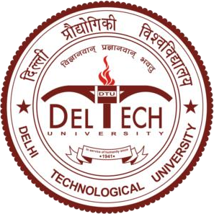**Varun Kumar (2K19/IT/140)**

**DEPARTMENT OF INFORMATION TECHNOLOGY**

**DELHI TECHNOLOGICAL UNIVERSITY**

**(Formerly Delhi College of Engineering)**

**Bawana Road, New Delhi-110042**

# CERTIFICATE

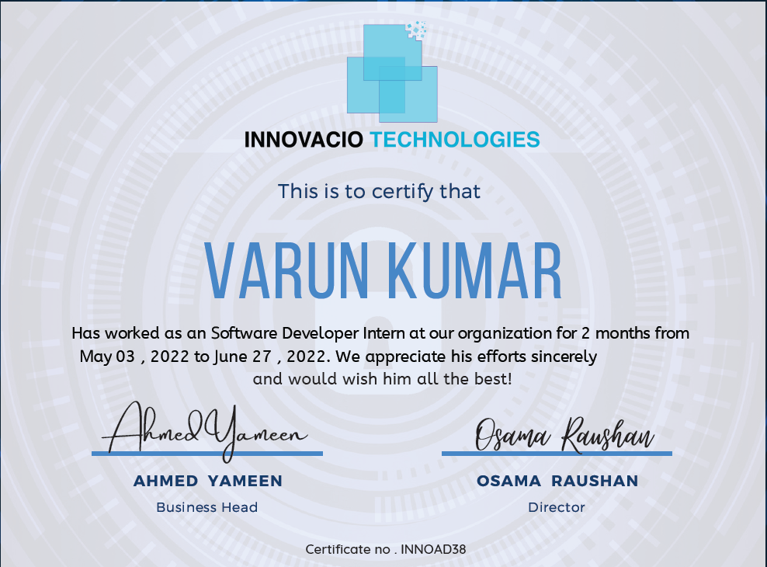

# Acknowledgement

The internship opportunity I got at Innovacio Technologies was a Software Developer Intern

I would like to express my gratitude and thanks towards my mentor Shamsuddin. He/She helped me in my projects and team engagement activities and provided good insights and advice that will be helpful in developing my career.

I would also like to thank my Company Buddy who guided me in my projects and provided weekly assistance on everything related to technical, non-technical, corporate culture etc.

Few more thanks to Osama Raushan.

Sincerely, Varun

##### Contents

1. Introduction 5

About Company

1. Before the internship 6
   1. Selection Process
   2. Job Profile
2. Tools and Technologies used 7
3. Week Wise report 8
   1. Week 1
   2. Week 2
   3. Week 3
   4. Week 4
   5. Week 5
   6. Week 6
   7. Week 7
   8. Week 8
4. Outcomes and Learning 16

## INTRODUCTION

About Company

Innovacio Technologies is a technology powerhouse that provides customized digital solutions to clients and customers making their business efficient and enhancing enterprise revenue. We provide customized solutions for - Web and Mobile Applications | Game Development | Artificial Intelligence | Machine Learning | Desktop software | Enterprise software | ERP | CRM | Chatbots | IOT and Embedded sytems| firmware Development | pcb designing

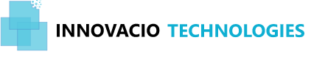

Their aim is to make technology affordable and available to every sector of the society and empower people through our work and innovation.

They strive to provide efficient and smart solution so that their dreams and businesses thrive

Innovacio strive to revolutionize the technology industry with our in depth knowledge and expertise and build a brand to reckon with

**2.** **BEFORE THE INTERNSHIP**

#### Selection Process

In the month of may, I applied thorough Internshala for sde internship at Innovacio Technologies.

After 3 days, I got call from them after shortlisting based on resume and Interview round scheduled.

Interviewer is happy with my responses and selected me as intern.

* 1. Job Profile

I was hired by Innovacio Technologies for the position of the Software Developer Intern. The job has the following duties:

* Understanding about the project and its scope.
* Understanding the technical aspects required to kickstart the project.
* Designing the architecture of the project.
* Designing a detailed design document for the project and keeping it up-to-date.
* Maintaining good quality of code using sound software engineering practices such as good error handling.

### TOOLS AND TECHNOLOGIES USED:

### HTML

### CSS

### JAVASCRIPT

### REACT.JS

### NEXT.JS

### MATERIAL UI

### NODE.JS

### EXPRESS.JS

### MONGODB

### SOCKET.IO

### GIT

### CLOUDINARY

1. **WEEK WISE REPORT**

#### Week 1

The majority of the first week went into onboarding with the team. A good amount of the time was contributed to learning about Innovacio’s values and comprehension of the working of the vast technology stack at Innovacio Technologies.

I had a 1-1 meeting with my manager and mentor and we also conducted several daily meetings and standups to synchronize, understand and discuss the project and it’s different aspects such as scope, expected duration, trade-offs, technologies, database, and decided a week-wise breakdown of the schedule for the duration of my summer internship. My project was primarily focused on React-Node.js.

#### Week 2

The second week of the internship was mainly focused on understanding the problem statement and designing the architecture of the project.

A huge part of this week was devoted to discussing various design techniques with my mentor and after numerous discussions we arrived at a desired architecture considering various methodologies.

So basically I worked on project that connects the developers by sharing posts, building connections and real time meet and chats.

Created frontend of Login / Signup Page using react.js, tailwind css, and material UI and connect to backend database mongodb through Node.js as backend technology

#### Week 3

The majority of work done in this week was reading the documentation of Next.js and writing the code base and designing the backend of the website.

A good amount of time was spent on learning about different technologies such as Git, json web token, mongodb etc.

Designed the User model.

Completed the Home page design and developement and connected it with backend.

#### Week 4

The majority of work done in this week is designing and developing the profile page of the user.

In the backend Designing the database for profile Model.

At this point of time I had a good understanding of databases

While doing the coding part I stumbled upon various obstacles and took help from my mentor, other team members and read documentation about various tools and technologies online.

#### Week 5

The majority of work done in this week was designing and developing the personal chat and group chat feature .

A lot of time was spent testing all the APIs involved. I debugged all the functions written in this week, followed preferred engineering practices and wrote code for the rest of the functions.

Also learned how to work with sockets and how to establish connections between frontend and backend.

This was the most challenging part of the project as I had to navigate through the whole repo for each buggy API, in order to ensure software quality.

#### Week 6

The majority of work done in this week was designing and developing the Meet features for the users.

Designing the frontend and connecting to backend.

Also learned how to work with p2p architecture and how to establish connections between frontend and backend.

This was the most challenging part of the project as I had to navigate through the whole repo for each buggy API, in order to ensure software quality.

#### Week 7

The majority of work done in this week was designing and developing the

Notifications feature for the user

Users will get all types of notifications.

A lot of time was spent testing all the APIs involved. I debugged all the functions written in this week, followed preferred engineering practices and wrote code for the rest of the functions.

Also learned how to work with p2p architecture and how to establish connections between frontend and backend.

#### Week 8

The work done this week was divided majorly into 2 parts : First was creating a documentation about the work done and second was ensuring code quality with my mentor for everything I wrote.

I created confluence articles for the feature I created and my progress as well. And after having a couple of sessions with my mentor I rewrote a few classes and functions to improve coding standards of the repo, and tested the whole repo again. After that I started planning the presentation.

The majority of work done in this week was preparing the presentation of the project for the final demo which was held towards the end of the week

##### 5. OUTCOMES AND LEARNINGS

I learned a lot of new things regarding Software Development with this summer internship.

Exhibit critical thinking and problem-solving skills by analyzing underlying issues to challenges.

I never had a chance to coordinate with a team before. Moreover, I got exposure to some of the practical Software Development practices employed while building any new product.

I learned the importance of designing over implementation. Even beyond that, I got the gist of Backend Development and integration of Databases.

I got to experience a rich technology stack present at Innovacio Technologies as well as some of the recent and habitually used technologies in the field of Software Development.

I realized the importance of communication in the technical field which helped me improve my software skills in the process. Once again, I would like to thank my mentors, Innovacio Technologies for giving me the opportunity to hone my skills and augment my potential.

………………………….